Bangladesh Medical Association (BMA)
List of Life Member-12
02. BMA Bandarban Branch

Sl No | Voter No | Voter Details
1 | Voter No  LM-0200001  No Image | DR. MD. FAIZ AHMED KHAN  F/Name:  M/Name:  BM & DC Reg. No:  NID:  Cell:  Address:  Blood Group:  TRANSFERED to BMA Dhaka City  LM-1405543
2 | Voter No  LM-0200002  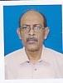 | DR. SUVASH DAS  F/Name:  M/Name:  BM & DC Reg. No:  NID:  Cell:  Address: Civil Surgeion Khagrachari Bandarban  Blood Group:
3 | Voter No  LM-0200003  No Image | DR. MD. SHAH ALAM BHUIYAN  F/Name:  M/Name:  BM & DC Reg. No:  NID:  Cell:  Address:  Blood Group:  TRANSFERED to BMA Dhaka City  LM-1405543
4 | Voter No  LM-0200004  No Image | DR. MD. BELAL HOSSAIN  F/Name:  M/Name:  BM & DC Reg. No:  NID:  Cell:  Address:  Blood Group:  TRANSFERED to BMA Dhaka City  LM-1405543
5 | Voter No  LM-0200005  No Image | DR. MAUNG THA JYO  F/Name:  M/Name:  BM & DC Reg. No:  NID:  Cell:  Address: Upazilla Health Complex Satkania Chittagong.  Blood Group:
6 | Voter No  LM-0200006 | DR. MUHAMMAD ELIYAS  F/Name:  M/Name:  BM & DC Reg. No:  NID:  Cell:  Address: Thana Health Complex Rowangchari, Bandarban  Blood Group:
7 | Voter No  LM-0200007  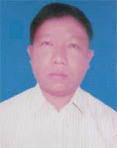 | DR. MONG HLA PRUE  F/Name: Manung Kyaw Ching  M/Name: Daw Mra U  BM & DC Reg. No: 27846  NID: 0321405114404  Cell: 01556606955  Address: Hospital Quater, Sadar Hospital, Bandarban  Blood Group: A+
8 | Voter No  LM-0200008  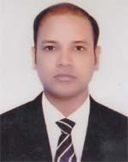 | DR. SAMIRAN NANDY  F/Name: Santosh Kumer Nandy  M/Name: Ratna Nandy  BM & DC Reg. No: 58651  NID: 0321406117198  Cell: 01812343198  Address: Sadar Hospital Bandarban  Blood Group: B+
9 | Voter No  LM-0200009 | DR. USEING MARMA  F/Name: Maung Chowent  M/Name: Ruby Chowdhury  BM & DC Reg. No: 57473  NID: 19852424709173  Cell: 01781641219  Address: Civil Sergon, Bandarban  Blood Group: B+
10 | Voter No  LM-0200010  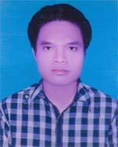 | DR. PROTTOSH POUL TRIPURA  F/Name: Satyaha Tripura  M/Name: Emaru Tripura  BM & DC Reg. No: 48398  NID: 1983272641088273  Cell: 01859674465  Address: Kalagrata no-3, Word, Bandarban Pourasova, Bandarban  Blood Group: O+
11 | Voter No  LM-0200011  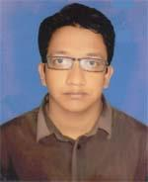 | DR. S.M. IQBAL HOSSAIN  F/Name: Muhammad Abdush Shakoor  M/Name: Hosne Ara Begum  BM & DC Reg. No: 63599  NID: 9196203120886  Cell: 01867171736  Address: 43/B, Shoilashova, Balaghata, Bandarban Sadar, Bandarban  Blood Group: A+
12 | Voter No  LM-0200012  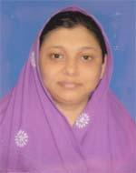 | DR. UMMUL BANIN  F/Name: Rashidun Nabi  M/Name: Reshma Rashid  BM & DC Reg. No: 63624  NID: 9196203131728  Cell: 01673791705  Address: Samar Vinigs-6D, 8/1, Enayet Noapara, Raojun, Chittagonj  Blood Group: AB+

